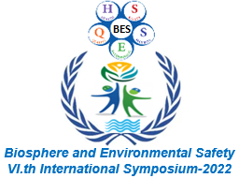
Registration Form of the VIth International Symposium–2022
Theme: “Biosphere & Environmental Safety”
May 5-6, 2022 Óbuda University, Budapest, Hungary
www.iceee.hu

Personal information (underline and complete)

Title: Mr. Ms. BSc. student MSc. student PhD student Eng. Dr. Prof. Other
First name (Your name not in short):
Last name (Family name):
Nationality:
Work place:
City:
Country:
Postal Address:
Mobile:
E-mail:

Technical information (underline and complete):

Presentation type: Oral Poster

I want to present one or two article(s):

- 1st presentation (oral / poster) title:

- 2nd presentation (oral / poster) title:

