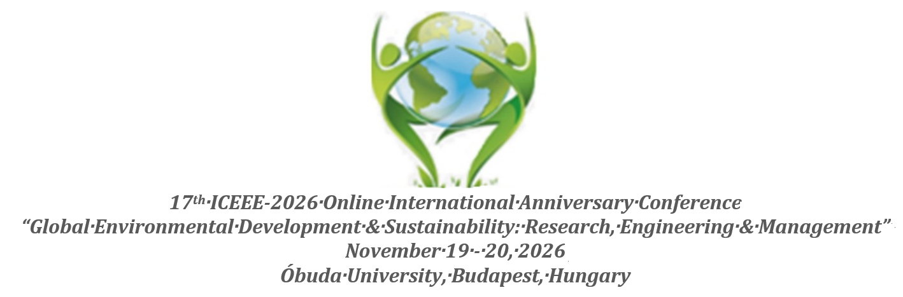

Title of the Manuscript
of the presentation (letter size: 16, Constantia)

Author(s) Name(s): First Name Sure Name (Letter size: 14, Constantia)

Work place(s), City, Country (NO MORE) (Letter size: 12, Constantia)

Manuscript preparation
It should be written in Constantia
Manuscripts should be organized in the following manner:
- Title,
- Author(s),
- Affiliation(s) of the author(s),
- Abstract,
- Keywords (up to seven),
- Introduction,
- Materials and methods,
- Results and discussion,
- Conclusions,
- Recommondation
- Acknowledgements (if relevant),
- References (in Roman script).

Authors are requested to ensure that abstracts give concise factual information about the objectives of the work, the methods used, the results obtained and the conclusions reached. A recommended length for the abstracts is 2.000 characters (with spaces).
The writing language of manuscripts is English (UK). A recommended length for the manuscripts is approx. 25.-35.000 characters (with spaces).
Manuscripts should be supplemented with the information about the author(s): name, position, organisation, main research areas, address, telephone and fax numbers, e-mail address.
When submitting a manuscript, please fill the information about all the authors, not only about the submitting one.

Abstract

Abstract text should not more than 500 words with letter size: 11. Please try to follow the instructions. No figures, no tables and no references. Abstract text should shortly contain: Background of the problem and aim(s), method(s) used, clear and important results, and ended by final conclusion(s)
Abstract should be enlightening and totally personal description, in brief present the topic, state the scope of the experiments, indicate significant data, and point out major results and conclusions. Complete sentences, active verbs, and the abstract should be written in the past tense. Standard nomenclature should be used and abbreviations should be avoided.

Keywords: not more 6 words (Letter size: 11)

introduction

Should be clear and related to the topic. Introduction should provide a clear statement of the problem, the relevant literature on the subject, and the proposed approach or solution. It should be comprehensible to academicians around the globe of scientific disciplines.

MATERIALS AND METHODS

Should be clear and shortly. Subheadings should be used. Methods, procedure or formula use should be complete enough to allow experiments to be reproduced. However, only authentic procedures should be described in detail; previously published procedures should be cited, and significant modifications of published procedures should be stated in brief.

Results AND DISCUSSION

Results should be presented with clearness and accuracy. The results, procedure should be written when describing the authors' analysis, theory test, investigation and experimental outcomes. Previously published results should be written as in present events. Results should be explained fundamentally with its outcomes. Title of table should be over the table and the title of the figure should be written below the figure. Tables and figures should be centric.
Tables and figures should be kept to a minimum and be designed to be as simple as possible. Tables should be self-explanatory. Figures should be prepared using applications capable of generating high resolution GIF, TIFF, JPEG or PowerPoint before pasting in the Microsoft Word manuscript file. Graphics should be supplied as high resolution (at least 300 d.p.i.) electronic files.
Tables should be prepared in Microsoft Word. Use Arabic numerals to designate figures and upper case letters for their parts (Figure 1). Tables should be self-contained and the data should not be duplicated in figures. All abbreviations should be defined in footnotes. Use superscript letters (not numbers) for footnotes and keep footnotes to a minimum.

The discussion should interpret the results in view of the results obtained in this and in past studies on this topic. State the conclusions in a few sentences at the end of the paper. The Results and Discussion sections can include subheadings, and when appropriate, both sections can be combined.

Conclusion

The main conclusions of the experimental work should be presented. The contribution of the work to the scientific community and its economic implications should be emphasized.

Acknowledgments

references

In the text, a reference identified by means of an author‘s name should be followed by the date of the reference in parentheses (year). When there are more than two authors, only the first author‘s name should be mentioned, followed by ’et al‘. In the event that an author cited has had two or more works published during the same year, the reference, both in the text and in the reference list, should be identified by a lower case letter like ’a‘ and ’b‘ after the date to distinguish the works.
For Example:
[1] Bayoumi Hamuda H.E.A.F., Ligetvári F.: Impacts of municipal sewage sludge on dynamics of organic matter and biological activities in clay loam brown forest soil. Journal of Residual Science & Technology, 2011, 8: 143-149.
[2] Bayoumi Hamuda H.E.A.F.: Biosecurity strategy for agricultural and food industry. Proceedings Book of the International Scientific practical Conference „Food, Technologies and Health-2014” 13 November 2014, Plovdiv, Bulgaria in CD pp: 156-161. ISSN 2367-6213
[3] Bayoumi Hamuda H.E.A.F., Paukó A., Bálint Á.: Impact of engineered metal oxide nanoparticles on plant-growth promoting substances produced by symbiotic N2-fixing Rhizobium. The 11th Edition Proceedings of International Multidisciplinary Conference, 20-22 May, 2015, University College of Nyíregyháza, Faculty of Engineering and Agriculture, Nyíregyháza, Hungary. pp. 29-34. ISBN978-615-5545-51-1
[4] Pimentel D., Greiner A.: Economic and Socio-Economic Costs of Pesticide Use. In Techniques for Reducing Pesticide Use: Economic and Environmental Benefits. Ed. Pimentel D. Chichester, UK: John Wiley, 1997, pp. 51-78
[5] Kirschner A.K.T., Kavka G.G., Velimirov B., Reischer G.H., Mach R.L., Farnleitner A.H.: Microbiological water quality and DNA based quantitative microbial source tracking. In: Liska I., Wagner F., Slobodnik J. (Eds.), Joint Danube Survey 2, Final Scientific Report. ICPDR, Vienna, Austria, 2008, pp. 86-95.
[6] IAASTD: Global Report. International Assessment of Agricultural Knowledge, Science and Technology for Development. Johannesburg. 2008Available at: www.agassessment.org.

Corresponding address: (Letter size: 10)
Name: Title (Prof., Dr., Mr., Mrs., or Miss) First name sure name
Department:
Faculty:
University:
Post Address: Zip code, Street, building number
City, Country
Telephone/mobile:
E-mail:

